Contents

1 🔧What’s New 2

2 🚀 Fixed Defects 2

3 🚀 Fixed Issues 3

4 Accessibility fixes 3

5 ⭐ Improvements 3

6 🚀 Deployments 4

6.1 Infrastructure 4

6.1.1 File Updates 4

6.1.2 Deployments 4

6.1.3 CKAN 5

6.2 CRM 7

6.2.1 Import TASMU_CPM_Core solution manually 7

6.2.2 Deployment 7

6.2.3 CRM Post Deployment Verification 7

6.2.4 CRM Email Template Links Update 7

6.3 CDN 8

6.4 Web Apps 8

6.5 Platform APIs 8

6.6 Bot 8

6.7 Mobile 8

6.8 Developer Portal 8

7 💻 Reviewers 9

8 Appendix 10

8.1 Post Deployment Verification 10

8.2 Running Pipeline from Tags 10

Release Notes

# 🔧What’s New

New user stories delivered:

| **ID** | **Title** | **State** |
| --- | --- | --- |
| [35990](https://dev.azure.com/TASMUCP/TASMU%20MSI/_workitems/edit/35990) | As a B2B/B2C Portal user, I should be able to see the correct Contact details on Contact us page. | DOD Ready |

**Logo Change for B2B(Marketplace), Account Portal, Open Data Portal and Developer Portal is implemented**

# 🚀 Fixed Defects

The following bugs reported in SIT are addressed in the current interim build –

| **ID** | **Title** | **Severity** | **Priority** |
| --- | --- | --- | --- |
| [33599](https://dev.azure.com/TASMUCP/TASMU%20MSI/_workitems/edit/33599) | FN - Chatbot - Safari/Chrome/Edge - User is unable to initiate a fresh chat, once user has left a message. | 3 - Medium | 2 |
| [35854](https://dev.azure.com/TASMUCP/TASMU%20MSI/_workitems/edit/35854) | FN- B2C My TASMU App- Android- Tool tip doesn't show for a newly registered user | 4 - Low | 2 |
| [35907](https://dev.azure.com/TASMUCP/TASMU%20MSI/_workitems/edit/35907) | FN - MarketPlace Portal - Footer Links are not correct | 3 - Medium | 2 |
| [35931](https://dev.azure.com/TASMUCP/TASMU%20MSI/_workitems/edit/35931) | NF-Work Order Arabic Notifications - (Email/Sms) Status is shown in English for Arabic Profile | 3 - Medium | 2 |
| [35951](https://dev.azure.com/TASMUCP/TASMU%20MSI/_workitems/edit/35951) | FN- iOS-Android - Push Notification does not appear on the ring of the app | 4 - Low | 2 |
| [35953](https://dev.azure.com/TASMUCP/TASMU%20MSI/_workitems/edit/35953) | NF-Localization-B2B- Eligibility message is shown in English for Arabic version | 3 - Medium | 2 |

# 🚀 Fixed Issues

The following issues reported are addressed in the current build –

|  |  |  |  |
| --- | --- | --- | --- |
| ID | Type | Title | Priority |
| [34580](https://dev.azure.com/TASMUCP/TASMU%20MSI/_workitems/edit/34580) | Issue | Enabling of HTTP 2.0 | 2 |
| [35154](https://dev.azure.com/TASMUCP/TASMU%20MSI/_workitems/edit/35154) | Issue | Regression Test Cycle- Co branded Logo Not available | 2 |

# Accessibility fixes

The following issues related to accessibility have been addressed in this build –

| **ID** | **Title** | **Priority** |
| --- | --- | --- |
| [35008](https://dev.azure.com/TASMUCP/TASMU%20MSI/_workitems/edit/35008) | NF-Accessibility-IOS iPhone Application-Home Screen-chatbot | 2 |

# ⭐ Improvements

1. Supporting more HTML tags for About TASMU and News Articles from CMS end.

# 🚀 Deployments

## Infrastructure

Pull Request – [Pull request 6869: Merge TASMU CP into TASMU MSI - 17 May 2021 - Repos (azure.com)](https://dev.azure.com/TASMUCP/TASMU%20MSI/_git/infra/pullrequest/6869)

### File Updates

1. Update the value for *CMS.Function.SupportedHtmlTags* key in /Scripts/AppConfigurations/settings/pre/appsettings.json

/Scripts/AppConfigurations/settings/prd/appsettings.json

Refer the PR [Pull request 6832: Adding More HTML Tags - Repos (azure.com)](https://dev.azure.com/TASMUCP/TASMU%20Central%20Platform/_git/infra/pullrequest/6832?_a=files)

1. Update parameter files for enabling http2 ([refer this PR](https://dev.azure.com/TASMUCP/TASMU%20Central%20Platform/_git/infra/pullrequest/6881?_a=files)) -
   1. agw-<sub>-apps-aks-<env>-we-01
   2. agw-<sub>-apps-api-<env>-we-01
   3. agw-<sub>-apps-ntf-<env>-we-01
   4. agw-<sub>-apps-web-<env>-we-01

### Deployments

1. Enable http2 for **agw-<sub>-apps-aks-<env>-we-01** manually from the portal -

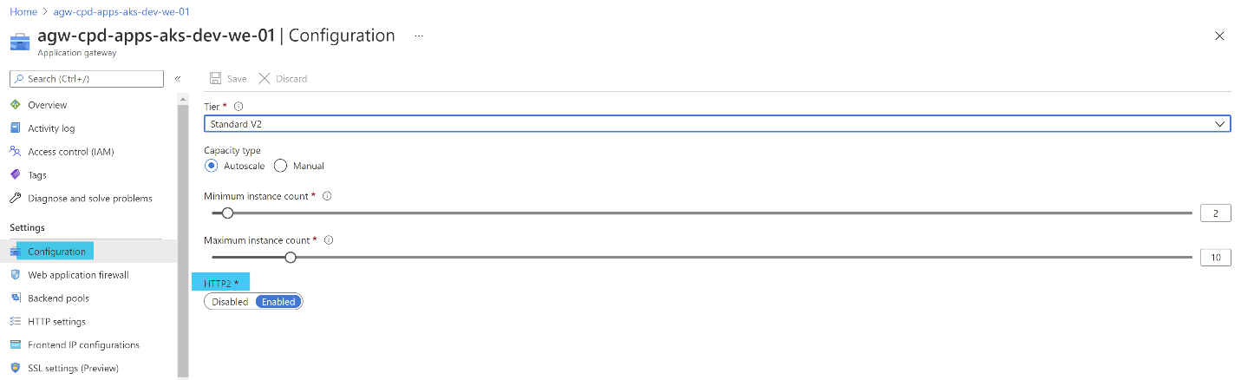

1. Run these pipelines -
   1. CD-AppConfigurations-Master-Release
   2. CD-rg-<sub>-apps-**waf**-<env>-we-01-Master-Release

### CKAN

1. Update the logic app parameters file **logic-<sub>-apps-purvckan-<env>-we-01-parameters.json**.  
   Refer to PR: <https://dev.azure.com/TASMUCP/TASMU%20Central%20Platform/_git/infra/pullrequest/6828>
2. Run the CD-pipeline: **CD-rg-<sub>-apps-ckan-<env>-we-01-Master-Release**.
3. Copy latest **ckanfiles** from **stcpdappsckanuatwe01** to **st<sub>appsckan<env>we01.**
4. Run the following commands in all the 3 Frontend VMs (**ckanfeapps<env>we<n>**) -
   1. sudo vi /opt/bitnami/ckan/venv/src/ckan/ckan/templates/footer.html
      1. Change first div class from **col-md-8** to **col-md-6**
      2. Add new div code for footer logo -   
         <div class="col-md-3">

{% block footer_logo %}

<a class="motctmlogo" href="{{ h.url_for('home.index') }}"><img height="32" src="/base/images/ckan-footerlogo-white.png" alt="{{ g.site_title }}" title="{{ g.site_title }}" /></a>

{% endblock %}

</div>

* + 1. Change last div class from **col-md-4** to **col-md-3**

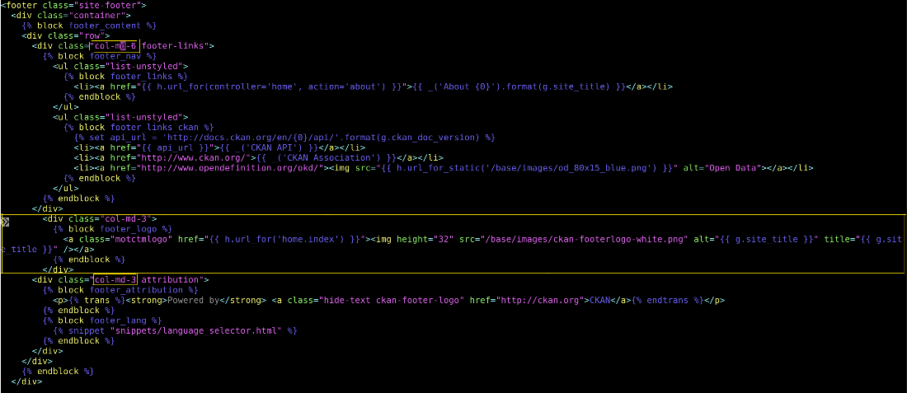

* 1. sudo vi /opt/bitnami/ckan/venv/src/ckan/ckan/templates/header.html  
     On line 75 add – height=”50”



* 1. **Generate SAS Key for ckanfiles in st<sub>appsckan<env>we01**
  2. cd /opt/bitnami/ckan/venv/src/ckan/ckanext/ckanext-tasmu_theme/ckanext/tasmu_theme/public/base
  3. sudo ~/azcopy_linux_amd64_10.10.0/azcopy copy "https://**stcpdappsckan<env>we01**.blob.core.windows.net/ckanfiles/ckanext-tasmu_theme/ckanext/tasmu_theme/public/base/images?**<use-sas-key-with-all-permissions>**" . --overwrite=prompt --check-md5 FailIfDifferent --from-to=BlobLocal –recursive
  4. cd /opt/bitnami/ckan/venv/src/ckan/ckanext/ckanext-tasmu_theme/ckanext/tasmu_theme/public
  5. sudo ~/azcopy_linux_amd64_10.10.0/azcopy copy "https://**stcpdappsckan<env>we01**.blob.core.windows.net/ckanfiles/ckanext-tasmu_theme/ckanext/tasmu_theme/public/tasmu_theme.css?**<use-sas-key-with-all-permissions>**" . --overwrite=prompt --check-md5 FailIfDifferent --from-to=BlobLocal --recursive
  6. cd /opt/bitnami/ckan/venv/src/ckan/ckanext/ckanext-tasmu_theme
  7. sudo python setup.py develop
  8. sudo service bitnami restart

## CRM

### Import TASMU_CPM_Core solution manually

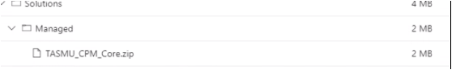  
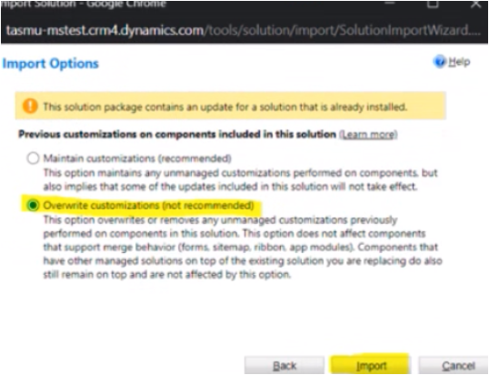

### Deployment

|  |  |
| --- | --- |
| **Build Id** | **Pipeline Name** |
| 42930 | [CD-CrmPlatform-Release](https://dev.azure.com/TASMUCP/TASMU%20Central%20Platform/_build/results?buildId=42930&view=results) |

### CRM Post Deployment Verification

[Verify workflows are activated from deployment guide](https://dev.azure.com/TASMUCP/TASMU%20Central%20Platform/_wiki/wikis/TASMU-Central-Platform.wiki/137/Dynamics-365-Deployment-Guide) (Refer 5.16 section)

### CRM Email Template Links Update

[Link to be changed in Email templates in CRM and Images needs to be uploaded for Prod](https://dev.azure.com/TASMUCP/TASMU%20Central%20Platform/_wiki/wikis/TASMU-Central-Platform.wiki/137/Dynamics-365-Deployment-Guide?anchor=5.17-email-templates-in-crm-and-images-needs-to-be-uploaded-for-prod) (Refer 5.17 section)

## CDN

|  |  |
| --- | --- |
| **Tag** | **Pipeline Name** |
| SIT_CDN_18May2021 | [CD-CDNContainer-Prd-Release](https://dev.azure.com/TASMUCP/TASMU%20Central%20Platform/_build?definitionId=1019) |

## Web Apps

|  |  |
| --- | --- |
| **Tag** | **Pipeline Name** |
| SIT_Web_18May2021 | [CD-WebApps-Prd-Release](https://dev.azure.com/TASMUCP/TASMU%20Central%20Platform/_build?definitionId=1020) |

## Platform APIs

|  |  |
| --- | --- |
| **Tag** | **Pipeline Name** |
| SIT_API_18May2021 | [CD-PlatformAPIs-Prd-Release](https://dev.azure.com/TASMUCP/TASMU%20Central%20Platform/_build?definitionId=1021) |

## Bot

|  |  |
| --- | --- |
| **Tag** | **Pipeline Name** |
| SIT_Bot_18May2021 | [CD-BotApi-Prd-Release](https://dev.azure.com/TASMUCP/TASMU%20Central%20Platform/_build?definitionId=1022) |

## Mobile

|  |  |  |
| --- | --- | --- |
| **Platform** | **Build Id** | **Pipeline Link** |
| Android | 42763 | <https://dev.azure.com/TASMUCP/TASMU%20Central%20Platform/_build/results?buildId=42763&view=results> |
| iOS | 42764 | <https://dev.azure.com/TASMUCP/TASMU%20Central%20Platform/_build/results?buildId=42764&view=results> |

## Developer Portal

**Remove lock** from rg-<sub>-shrd-<env>-we-01 for apim-<sub>-shrd-<env>-we-01

|  |  |
| --- | --- |
| **Branch** | **Pipeline Name** |
| master | [CD-APIMDevPortal-rg-cpp-shrd-pre-we-01-Release](https://dev.azure.com/TASMUCP/TASMU%20Central%20Platform/_build?definitionId=963) |

Go to apim-<sub>-shrd-<env>-we-01 and publish the developer portal.

[Refer Step 3](https://dev.azure.com/TASMUCP/TASMU%20Central%20Platform/_git/apim-devportal?anchor=migrating-developer-portal) for detailed screenshot.

# 💻 Reviewers

|  |  |
| --- | --- |
| Prepared By | Manvir Kaur, Sumit Gupta |
| Company name | Microsoft |
| Reviewed by | Ravi Sankar Pillutla, Anil Erkek, Subhajit Chatterjee, Gareeb Navas T M, Mecit Atmaca |
| Approved by | Ashwani Sharma |

# Appendix

## Post Deployment Verification

Function Apps Running

<https://func-cpp-apps-ckan-pre-we-01.azurewebsites.net/>

<https://func-cpp-apps-qnasync-pre-we-01.azurewebsites.net/>

<https://func-cpp-apps-luistra-pre-we-01.azurewebsites.net/>

<https://func-cpp-apps-intbpa-pre-we-01.azurewebsites.net/>

<https://func-cpp-apps-intntf-pre-we-01.azurewebsites.net/>

<https://func-cpp-apps-pt-pre-we-01.azurewebsites.net/>

Marketplace Portal - <https://marketplace.pre.sqcp.qa/en/>

Bot – Chat with bot on marketplace

My Tasmu Portal - <https://mytasmu.pre.sqcp.qa/en/>

Account Portal - <https://account.pre.sqcp.qa/en/>

Admin Portal Portal - [https://cpadmin.pre.sqcp.qa](https://cpadmin.pre.sqcp.qa/)  (Login screen should come)

API Config access - <https://api.pre.sqcp.qa/config/api/feature>

Open Data Portal - <https://opendata.pre.sqcp.qa/>

## Running Pipeline from Tags

